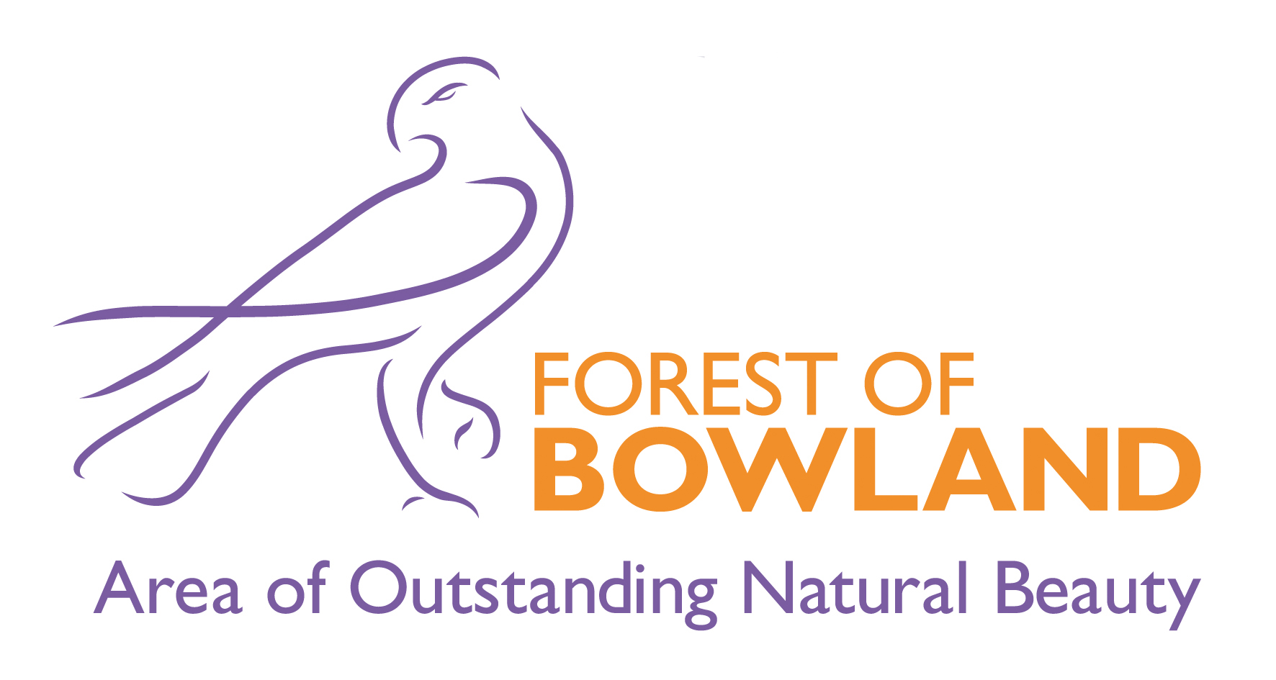

Forest of Bowland Area of Outstanding Natural Beauty Joint Advisory Committee

Minutes of the Meeting held on Wednesday, 18th April, 2012 at 2.00 pm in Foster Suite, Hornby Community Resource Centre, The Institute

Present:

Chair
County Councillor Albert Atkinson, Lancashire County Council
Committee Members
County Councillor Mrs Susie Charles, Lancashire County Council
Councillor Lin Barrington, Craven District Council
Councillor Roger W Brooks, Wyre Borough Council
Neil Clark, Natural England
Andrew Gouldstone, RSPB
Michael Helm, LAPTC
David Kelly, Ramblers Association
Councillor Colin Price, Yorkshire Local Councils Association
County Councillor David Smith, Lancashire County Council
Mr Andrew Taylor, Bowland Landowners and Farmers Group
Dave Oyston, United Utilities plc

Officers
Hetty Byrne, Forest of Bowland AONB Unit
Cathy Hopley, Forest of Bowland AONB Unit
Elliott Lorimer, Forest of Bowland AONB Unit
Nick Osborne, Forest of Bowland AONB Unit
Sandra Silk, Forest Of Bowland AONB UNit
Vaughan Jones, Pendle Borough Council
Martin Putsey, Preston City Council
Alison Boden, Wyre Borough Council
Mike Williams, Pendle Borough Council

Apologies
Councillor John Browne, Preston City Council
Councillor Mrs Rosemary Elms, Ribble Valley Borough Council
Ian Grindy, United Utilities plc
County Councillor Richard Welch, North Yorkshire County Council
Graham Megson, North Yorkshire County Council
Greg Robinson, Wyre Borough Council

Welcome, introductions and apologies

The Chairman welcomed everyone to the meeting.

Minutes of the Meeting held on 17 October 2011

The minutes of the meeting held on the 17 October 2011 were presented.

Resolved: The minutes of the meeting held on the 17 October 2011 were agreed as a correct record.

Matters arising

Cath Hopley reported that the bid to the Nature Improvement Areas (NIAs) Programme had been unsuccessful. However, the Morecambe Bay bid was successful from Lancashire.

AONB Budget 2012/13 and Memorandum of Agreement update

Nick Osborne presented a revised and updated budget for 2012/13 and progress towards all funding authorities having signed the revised AONB Memorandum of Agreement (MoA).

Nick reported that the updated figures included grant from Defra of approximately £210k against core costs and £29k to support the AONB Sustainable Development Fund. This allowed an annual programme of projects, against strategic priorities and actions, to the value of approximately £85k. It was anticipated that projects funding would again be used as match funding to attract additional income.

In relation to the request from Defra that funding authorities enter into a revised 4 year MoA, Nick reported that four authorities had agreed to sign , with the remaining authorities all working towards agreement to sign in early 2012/13.

Nick also thanked members and officers for their continued support.

Resolved: That,

- the revised AONB budget for 2012/13 be noted, and
- the update on progress towards all funding authorities signing the revised AONB Memorandum of Agreement also be noted.

Delivering the AONB Management Plan

Elliott Lorimer presented a report summarising the progress made during 2011/12 towards delivery of the 'Year 1' targets in the business plan; detailing achievements, highlighting some key projects and activity and also the on-going annual review of the business plan. The vast majority of targets had been delivered with other well underway. He also presented the Plan for 2012/13 which contained no significant changes to last year's plan. However, there may need to be minor amendments following consultation with AONB partners.

Members of the Committee were pleased to note that progress, on the whole, was good. However, in view of the reduction in staff and resources, there were concerns at how performance would be maintained. In response, Elliott reassured members that the targets in the Business Plan would always have to reflect the resources available and if necessary Defra would have to be informed if works could not be completed as a result.

An update was requested in relation to the North Lancashire Bridleway Phase 2. It was felt that the bridleway links needed to be developed as soon as possible. Elliott promised to ask Tarja Wilson to get in touch. Alison Boden reported that the Core Strategy for Wyre was currently out for consultation and the inclusion of the North Lancashire Bridleway would be positive.

Cath Hopley presented the AONB Team report. She highlighted areas of particular interest including:

- A joint bid with the Yorkshire Dales Millennium Trust, to the Lancashire Environmental Fund to improve rich grasslands and in particular the upland hay meadows of the AONB, has secured £40,000 for an 18 month project which aims to restore over 20 sites.
- The walking trail (White Trail) from School Lane car park has been modified to facilitate tramper access along the whole 2.1km length of the route which will make the route suitable for tramper access at all times of the year. The route will be promoted through the Forest of Bowland website.
- The Forest of Bowland AONB was runner-up of the prestigious 'Best Destination' award from The International Responsible Tourism Awards. The award was presented to the AONB on 9 November as part of World Responsible Tourism Day at the World Travel Market in London, sponsored by Virgin Holidays. The accolade was testament to a collective effort of the AONB team, partner organisations, community groups and most of all the tourism businesses themselves who have worked hard over the last six years to deliver tourism with sustainability at the core.

Resolved: That,

- the reports on AONB team activity during 2011/12 be noted, and
- a 'working' AONB team business plan for 2012/13 be agreed, before presentation of the final plan at the next committee meeting in October 2012.

AONB Partner Updates

The Chairman opened the meeting to members of the Committee.

Alison Boden, Wyre Borough Council, reported that the Garstang Walking Festival was due to be held between the 11-20 May and would consist of 60 walks. New activities would include Wildflowers – Myths and Legends and Out to meet the cows.

She also reported on the Holme Wood Project which comprises 500m of footpath repair and improvement with the purpose of conserving the biodiversity and reducing erosion in the semi-natural woodland of Holme Wood.

The Wyre Ranger Service and the Lancashire Wildlife Trust had led 2 guided walks to help increase involvement in the Brown Hare Survey Project.

Alison also reported on Wyre's Core Strategy Consultation. The Strategy sets out Wyre's vision for growth and development of the entire borough over the next 16 years, and partners were encouraged to participate in the consultation.

Andrew Gouldstone, reported that the RSPB were working with a number of farms to protect wading birds, as well as working with the Ribble Rivers Trust. Of particular note was an education project where the Society was working with schools on a joint project with the AONB. He also reported that last year there were 10 breeding Hen Harrier pairs of which there were 4 successful nesting attempts. However, he had serious concerns this year that there may be no successful nesting attempts within Bowland. Andrew went on to highlight that one reason for lower numbers of nesting attempts in the area is continued human persecution of the species within the UK.

Dave Oyston, United Utilities reported that improvements to the east side of the Stocks Reservoir Circular Walk had been undertaken so that there was now no need to walk on the highway.

Resolved: That the report be noted.

'The Bowland Symposium', 1-2 May 2012

Hetty Byrne reminded members of the Committee that the Bowland Symposium was being held on the 1/2 May 2012 to showcase sustainable tourism within the AONB. The 2 day event was being held in response to lots of requests from other Protected Landscape areas from the Norfolk Broads to Norway.

Day 1 would be launched by the County Councillor Atkinson and consist of speakers and workshops. Attendees on day 2 would be able to take the opportunity to enjoy a number of visits to tourism businesses showcasing their accommodation, local produce, wildlife and everything that the Bowland area has to offer.

Members of the Committee were strongly encouraged to attend.

Resolved: That the report be noted.

Future development of AONB related organisations

Elliott Lorimer presented a report which summarised the progress made so far in relation to the AONB team business plan targets for 2011/12:

- to "investigate alternative forms of governance to assist in fund-raising (Friends of, Trusts etc)" and
- to hold "discussions with neighbouring protected landscape areas" about such developments. This report and seeks approval from the AONB Joint Advisory Committee for this development work to continue in 2012/13.

Given the planned reductions in central government funding from Defra for AONBs and the increasing pressures on local authority budgets over the current CSR period up to 2014/15, consideration of existing, or alternative, organisational structures for AONBs was on-going across England within individual AONBs, local authorities, the National Association of AONBs and Defra.

During 2011/12, the Principal AONB Officer and AONB Development and Funding Officer have carried out scoping work on existing AONB-related organisations which involved reviewing the current operations of existing AONB-related organisations and investigating the scope for increased fund-raising operations within these organisations.

- Discussions had been held with Nidderdale AONB, Shropshire Hills AONB and Yorkshire Dales Millennium Trust regarding alternative governance arrangements and operations. The Principal AONB Officer had also been investigating possible joint working with Arnside and Silverdale AONB where this may be of future benefit in bidding jointly for funds, dealing with corporate sponsorship, income generation etc.

The AONB team has been involved in national discussions, co-ordinated by the National Association of AONBs, on a potential role for Community Foundations in raising funds for AONBs in the future, and in developing both charitable and social enterprise models for AONB activity.

Elliott proposed that:

- discussions commence with trustees of Bowland Tourism Environment Fund to consider options for expanding its present focus on visitor contributions to become a more generic fund-raising body for the AONB; and to consider renaming the organisation as something more recognisable, such as Bowland Landscape Trust or Foundation, for example.

- a 'Friends of Bowland' be development and formally establishment of to help co-ordinate community support for- and volunteering activities in the AONB.

- a comprehensive funding-raising strategy for the AONB Partnership, involving all AONB-related organisations be developed which would identify how the various organisations could operate together effectively, and also identify potential sources of funds for them each to apply for.

Resolved:

The committee agreed to the continuation of the development of AONB-related organisations as detailed above, leading to a comprehensive fund-raising strategy being produced for the AONB Partnership.

Any other business

Members of the Committee offered their thanks for the support for the Lawkland Parish Lengthsman scheme which had been working very well.

Dates of Next Meetings

It was suggested and agreed that the next two meetings of the Committee be held:

- Tuesday 2nd October 2012 in Wyre
- Tuesday 9th April 2013 in Pendle

Andy Milroy
Principal Executive Support Officer
Lancashire County Council
County Hall
Preston

